**CHAPTER 2 – PROJECT MANAGEMENT PLAN**

**2.1. Problem Definition**

Chapter 1 – Introduction gave you a brief view about the reason why this project was chosen to develop. In this chapter 2 called Project Management Plan, we will discuss about project management, included project’s problems and risk management.

**2.1.1. Name of Capstone Project**

English name: Home Surveillance System

Vietnamese name: Hệ thống giám sát an ninh gia đình

**2.1.2. Problem Abstract**

The field home security is booming vigorously. However, companies which offering this solution have a downside – they will only provide an entire solution package of home surveillance monitoring with automated solution, typical of BKAV with SmartHome. The demand of market is so huge, but user do not have sufficient funding to find a compact monitoring solution and have effective at cost, not too expensive and of course, can be deployed immediately at existing house.

The first choice of people typically is a supplier which provides monitoring system solution via IP camera. But that fact that, IP camera is just only support solution, and it’s passive, has a lot of weak points when do the actual deployment. For example: The last observation IP Camera must always be carried out continuously from afar; appear the dead viewing angle (the camera range could not reach). Or when you are at home, the IP Camera will not promote effective supervision in a comprehensive way in many different positions (many floors or rooms).

HSS is launched to address the limitations of IP Camera by implementing a comprehensive monitoring solution, also put the IP camera into its own place in system architecture. Whether you're away from home or in another room, just a phone in hand with an Internet connection, HSS will alarm immediately on your phone for the suspicious activity (like opening the door or motion detection in particular room…).

Not only that, when you were away from home, a lot of people could visit your house, and rang the bell. HSS may notify immediately to your smartphone and initiating a connection to the bell module (speaker/microphone inside). Then, you can start a conversation with that person immediately.

**2.1.3. Boundaries of System**

The system under development of this Capstone Project will include:

* The app is a gateway installed on the Android user phone has the task of sending the request, as well as receiving the notifications from system
* A central circuit board has responsible for data exchange with the gateway through Raspberry and Arduino
* User manual, test document
* Design circuit broad, design document
* Source code Android application, Raspberry and Arduino

**2.2. Project Organization**

**2.2.1. Development Process Model**

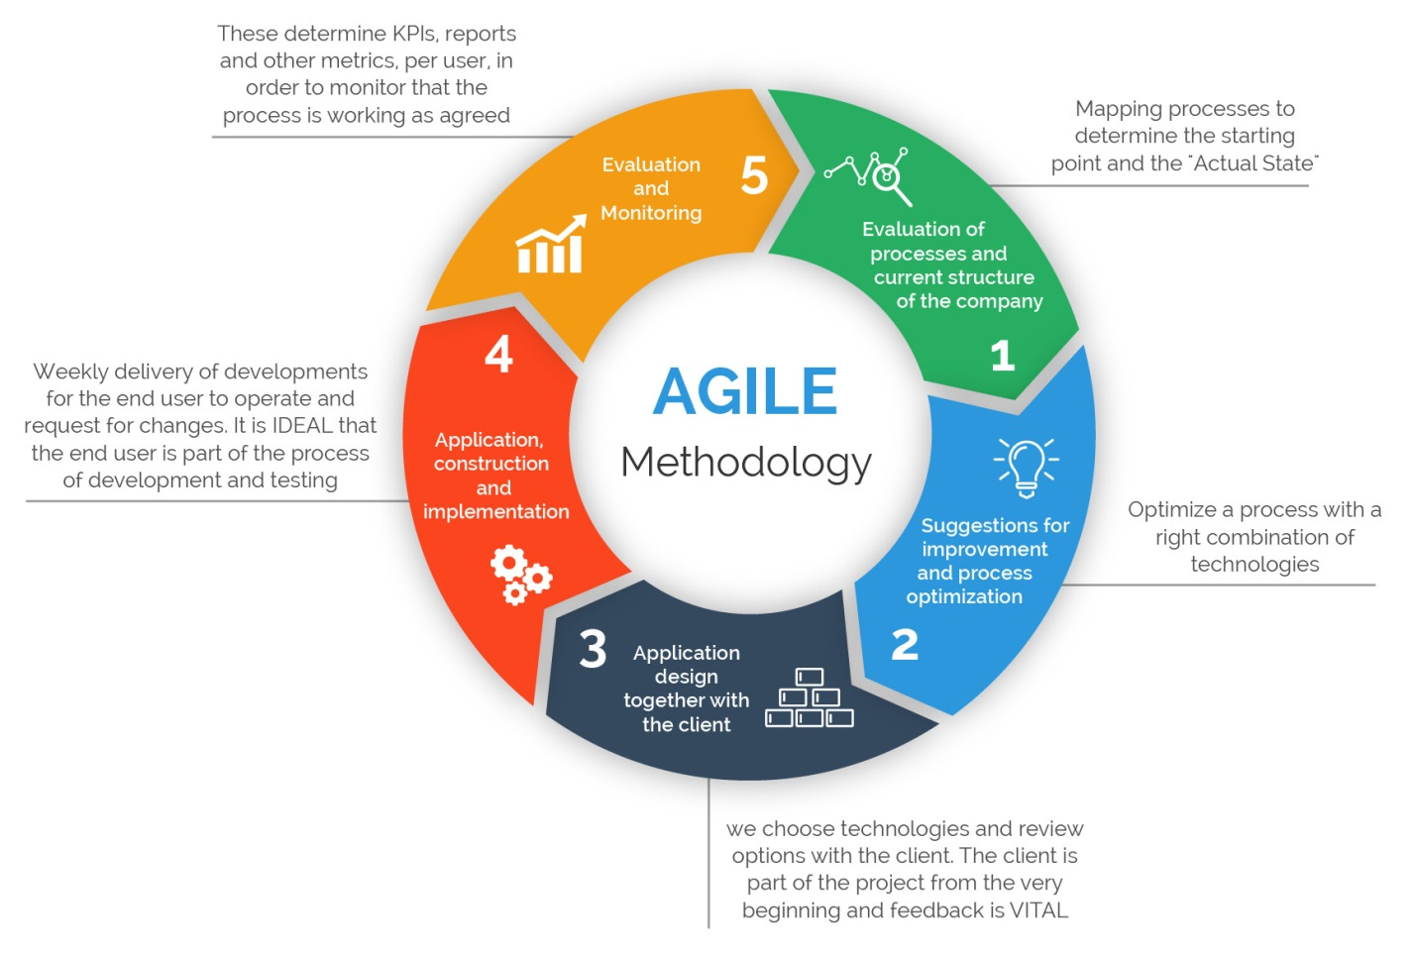

This figure above describes the information and products flow lifecycle process model. HSS project uses the Agile Development Process Model. It has 5 stages:

Stage 1: Evaluation of processes and current structure of the company: Mapping processes to determine the starting point and the “Actual State”

Stage 2: Suggestions for improvement and process optimization: Optimize a process with a right combination of technologies

Stage 3: Application design together with the client: we choose technologies and review options with the client. The client is part of the project from the very beginning and feedback is vital

Stage 4: Application, construction and implementation: Weekly delivery of developments for the end user to operate and request for changes. It’s ideal that the end user is part of the process of development and testing

Stage 5: Evaluation and Monitoring: These determine KPIs, reports and other metrics, per user, in order to monitor that the process is working as agreed

Why we chose this process model? Let’s take an overview look at advantages of Agile:

* Customer satisfaction by rapid, continuous delivery of useful software
* People and interactions are emphasized rather than process and tools. Customers, developers and testers constantly interact with each other
* Working software is delivered frequently (weeks rather than months)
* Face-to-face conversation is the best form of communication
* Close, daily cooperation between business people and developers
* Continuous attention to technical excellence and good design
* Regular adaptation to changing circumstances
* Even late changes in requirements are welcomed

By breaking down the project into manageable units, the project team can focus on high-quality development, testing, and collaboration. Also, by producing frequent builds and conducting testing and reviews during each iteration, quality is improved by finding and fixing defects quickly and identifying expectation mismatches early.

**2.2.2. Tools and Techniques**

**2.2.2.1. Tools**

|  |  |
| --- | --- |
| **Name** | **Description** |
| Microsoft Office 2013 |  |
| Microsoft Powerpoint 2013 |  |
| Microsoft Project 2013 |  |
| Microsoft Excel 2013 |  |
| Proteus 9 |  |
| Android SDK |  |
| Arduino 1.6.7 |  |
| Qt Creator |  |
| Google Drive |  |
| GitHub Desktop |  |
|  |  |
|  |  |
|  |  |
|  |  |
|  |  |

**2.2.2.2. Language and Techniques**

Programming language: C++, Java, XML, Python

Source code manager: GitHub

Service: Pusher/PushOver for push notification

**2.2.2.3. Hardware**

- Raspberry Pi B+

- Arduino Mega

- PIR sensor, magnetic switch, alarm

- Camera module

- Speaker/Mic module

- Wire, resistor, led, breadboard…

**2.2.3. Human Resources**

|  |  |  |
| --- | --- | --- |
| **Roles** | **Member** | **Responsibility** |
| Project Manager | CuongTV | Planning developing schedules, allocating resources, keeping on schedule, coordinating communication, generally responsible for keeping the team’s focus on main goal and tries to keep the project team focused on the right goal at a time |
| Hardware Technical Leader | CuongTV | Responsible for the underlying architecture for the hardware system |
| Software Technical Leader | DiepDTN | Responsible for the underlying architecture for the software system |
| Quality Assurance Manager | CuongTV | Ensuring the products meet the certain standards of quality from requirements. |
| Develop Team | DiepDTN, HungVT | Involve to code software block |
| Test Team | HungVT, DungDT | Involve to test system |
| Document Team | CuongTV, DungDT | Write document for system and reports |

**2.3. Project Management Plan**

<On process>

**2.4. Risk Management Plan**

**2.4.1. What is Risk Management?**

A risk is an event or condition that, if it occurs, could have a positive or negative effect on a project’s objectives. Risk Management is the process of identifying, assessing, responding to, monitoring, and reporting risks.

**2.4.2. Purpose of Risk Management**

This Risk Management Plan defines how risks associated with the HSS project will be identified, analyzed, and managed. It outlines how risk management activities will be performed, recorded, and monitored throughout the lifecycle of the project and provides templates and practices for recording and prioritizing risks.

**2.4.3. Risk Management Plan**

|  |  |  |  |  |  |  |  |
| --- | --- | --- | --- | --- | --- | --- | --- |
| **No** | **Risk Name** | **Category** | **Description** | **Reason** | **Risk Owner** | **Impact** | **Response** |
| 1 | Over deadline | People | Did not submit task on time that it must be completed by | Didn’t work as planned, sickness or lack of attitude | Members | Very high | Leader had some penalties for all members |
| 2 | Conflict ideas | People | Conflict ideas or solution with another member | Poor communication, difference in personalities or values | All | High | Ask our lecture for ideas and stop making conflict |
| 3 | Cannot reach project scope | Technical | Could not reach project scope as our expectations | We couldn’t understand ourselves and our abilities, so think bigger but do smaller | All | Very high | Try our best to reach our maximum abilities |
| 4 | Unrealistic project schedule | Strategic | Unrealistic project schedule | Couldn’t manage well the schedule and did not understand members | Leader | High | Stay down and do the project schedule again |
| 5 | Hardware suddenly break | Technical | Hardware in comment (devices, components…) are suddenly break without any reason | Environment, weather, humidity or even quality of device… | N/I | Normal | This is objective reason so we could not handle it, due to limited project budget |
| 6 | Limited project budget | Technical | Could not get fully devices or components as the first scope overview and our expectations | Some devices and/or components are not cheap, so especially made some difficulties for us | All | High | Asking for borrow some components from friends and lecture |
| 7 | Working environment | Other | When internet connection is lost, all connection between Raspberry Pi and server lost, and can automatically connect again | Speed of internet in campus Hoa Lac is very slow. And login mechanism for using Internet in dormitory prevented us from working well with internet and Raspberry Pi | N/I | Very high | This is objective reason so we could not handle it |

**2.5. Communication Plan**

Communication must circulate through the project management leader and external stakeholders to maintain the health and the viability of the project. The existence of a documented communication plan does not by itself guarantee good communication during the project planning stage. Attention must be given to the type of information that is required at each level of the project and take steps to make sure that information is freely transmitted.

**2.5.1. Between team members**

* Weekly offline meeting: Monday’s night
* Un-scheduled meeting: when necessary and urgent
* Online discussing:
  + Facebook Group Chat
  + Facebook Group
* Synchronize/Support Tool: Google Drive, GitHub
* Mobile phone: when necessary and urgent

**2.5.2. Between members with supervisor**

* Weekly offline meeting: on Slot 4, 5 at Room 301L, Alpha building, FPT University campus Hoa Lac
* Online discussing: Email
* Mobile phone: when necessary and urgent